Transition Information
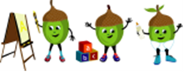
All About Me
Baby Room

My full name is:
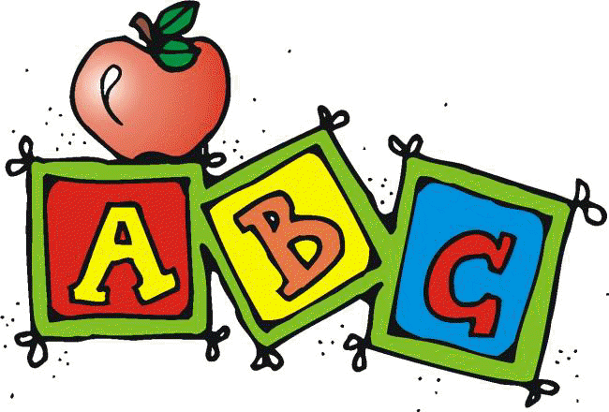 I like to be called:

My birthday is on:
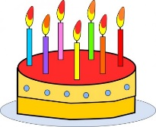

At home I like to:  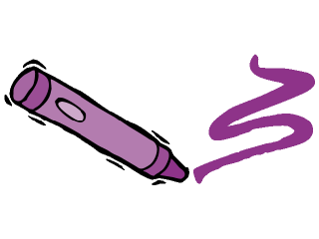 | I do not like to:

These people will bring and collect me from Nursery

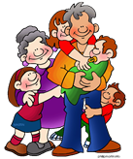

My favourite toys and comforters are:

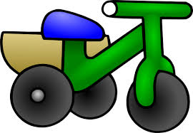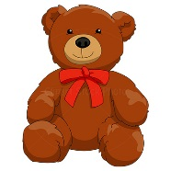

When I am having my nappy changed I like to:

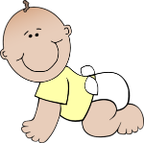

When I am tired I like:

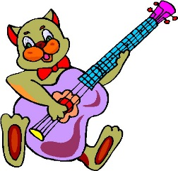

Sleep time/Routines:

Milk:
I can have cows milk on breakfast YES / NO
My formula milk is ________________________________________
I like my milk at these times_________________________________
I drink from a bottle / cup _______________________(Type of bottle)
I drink this much ________________________________________ oz

Any other information that might be useful ___________________________
_______________________________________________________________
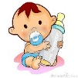

Food glorious food:

I like my food Blended/ Chopped/ Mashed or __________________________
My mealtimes are ______________________________________________________
I like to eat ______________________________________________________
I don’t like to eat ______________________________________________________
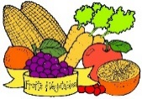

My favourite stories, Nursery Rhymes and Songs are:

What makes me happy:  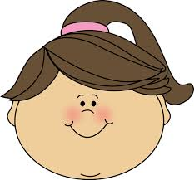 | What makes me sad:  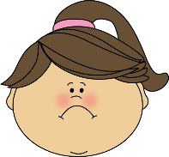
PRIVACY STATEMENT
Any information regarding you and your family is kept confidential and will not be passed to organisations without your consent, unless it is of a child protection nature, in which case the information will be shared with appropriate agencies. Cliff Nursery undertakes to keep all information provided securely and it will only be processed under the terms of the General Data Protection Regulation 2018 under the basis of legal obligation.

