Transition Information
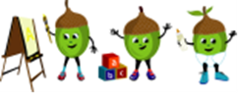
All About Me
Pre School Room

My full name is:
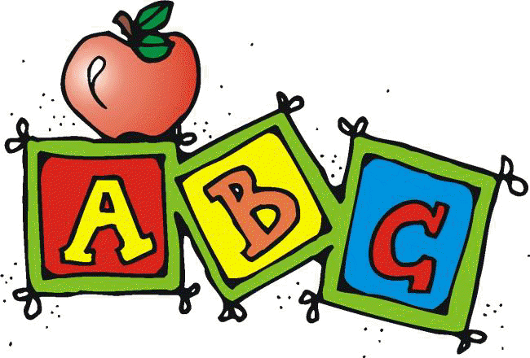 I like to be called:

My birthday is on:
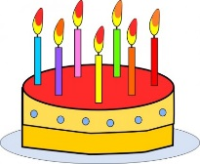

At home I like to:  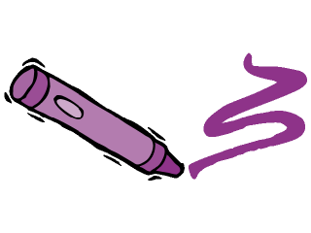 | I do not like to:

My favourite toys and comforters are:

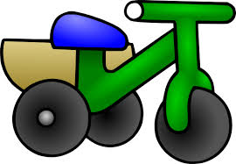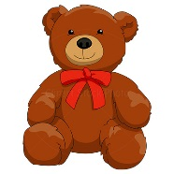

I wear nappies / pants:

Who lives in my house:

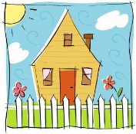

Allergies:

These people will bring and collect me from Nursery:
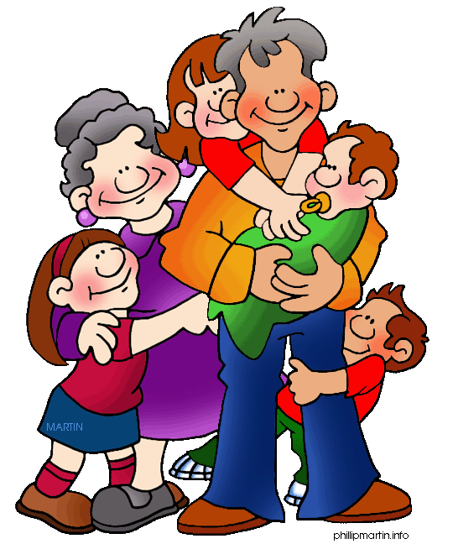

My favourite stories, Nursery Rhymes and Songs are:

What makes me happy:  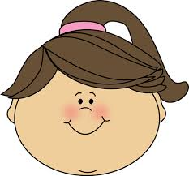 | What makes me sad:  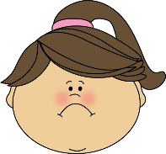

I am looking forward to:

At Nursery I am already friends with:

PRIVACY STATEMENT
Any information regarding you and your family is kept confidential and will not be passed to organisations without your consent, unless it is of a child protection nature, in which case the information will be shared with appropriate agencies. Cliff Nursery undertakes to keep all information provided securely and it will only be processed under the terms of the General Data Protection Regulation 2018 under the basis of legal obligation.

