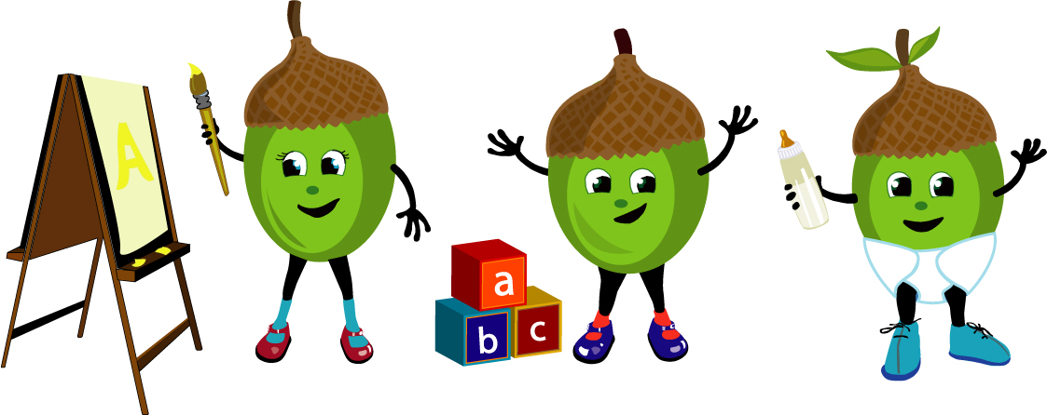Silkstone Newsletter

December 2016
Here we are again at this exciting time of year! We have the usual fun packed month planned before the big day. Nursery re opens after Christmas on Tuesday 3rd January. We would like to wish every one a Merry Christmas and a Happy New Year.

Security
We would like to thank all parents and carers for following our security procedures for not opening or holding the door open for others. This is for the safety of all children and staff. Thank you for your cooperation.

Outdoor Clothing 
Please can you ensure your child comes to Nursery with appropriate clothes for outdoor play. Such as a Wellies, Gloves and a Warm Hat and Coat.

Absence from Nursery
If your child is going to be absent from Nursery please could you inform us as early as possible.
Thank you for your cooperation.

Children In Need
Thank you to everyone for their support, we raised a fantastic £97.08
Preschool 1
Our Preschool 1 Christmas Production is the Night Before Christmas Singalong. This is taking place on Friday 16th at 10am. Each family will be allocated 2 tickets shortly.

Preschool 2 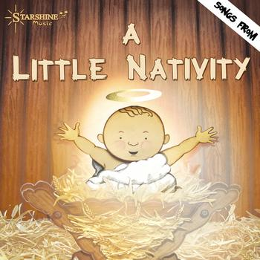
Our Preschool 2 Christmas Production, “Little Nativity” is taking place on Friday 16th at 1.30pm. Each family will be allocated with 2 tickets shortly.
School Leavers Trip to See Santa 
Children will be seeing Santa at The Potting Shed throughout the week of 5th December.

Christmas Lunch and Jumper Day 
We will be enjoying Mrs Lewington’s traditional Christmas lunch on Wednesday 14th December. Yum yum!!
Party Week 19-23 December 
To finish 2016 in style we will be partying all week. Lots of games and fun to be had by all.

Nursery Funding - Spring Term 2017
Spring term for Nursery funding is 12 weeks, commencing from Tuesday 3rd January to Friday 7th April with a two week half term break 13-24 February. Forms for parents to sign will be distributed at the beginning of the term.
Severe Weather 

With the arrival of the winter season, we would like to remind parents about our bad weather arrangements.
The Nursery’s priority is for the safety of its Children and staff. If weather reports confirm that transport is likely to be seriously affected, the decision to not open or to close nursery early will be taken as soon as possible so that all children and staff can return home safely. However we will endeavor to keep the Nursery open wherever possible. A text message will be sent to parents with updates regarding Nursery closures.

To ensure we hold the correct mobile telephone number on our texting system a test text will be sent to parents on Monday 5th December. If you do not receive this text please email nursery to advise and provide the number you would like to receive the text to. Our email address is info@silkstonenursery.co.uk
.

