Cliff Classics
Home Activity Ideas
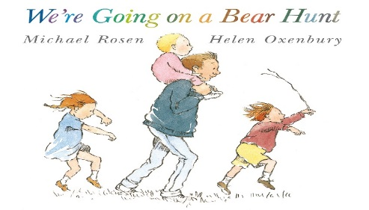
- A bear hunt through the woods, looking at colours, shapes and sizes.
- Collect items to make discovery bottles 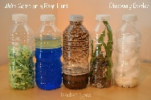
- Sensory play in the garden (bare foot) feeling the swishy swashy grass. Dig in the mud and add water. Talk about colours, change and what it feels like.
- Use ice cubes to look at change and temperature (Snowstorm)
- Hide a bear and encourage your child to retell the story whilst finding the bear.

- Enjoy a teddy bear picnic. 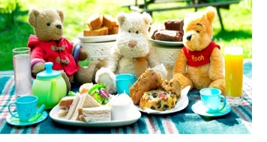

- Making dens (Bear cave)

- Paper plate bear hands and face masks

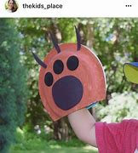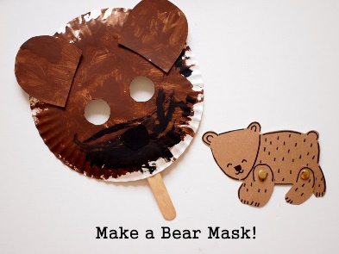

- Collect items to make a collage 